Atherington Argus
November 2019:Free to residents of Atherington Parish:Vol. 11 No11

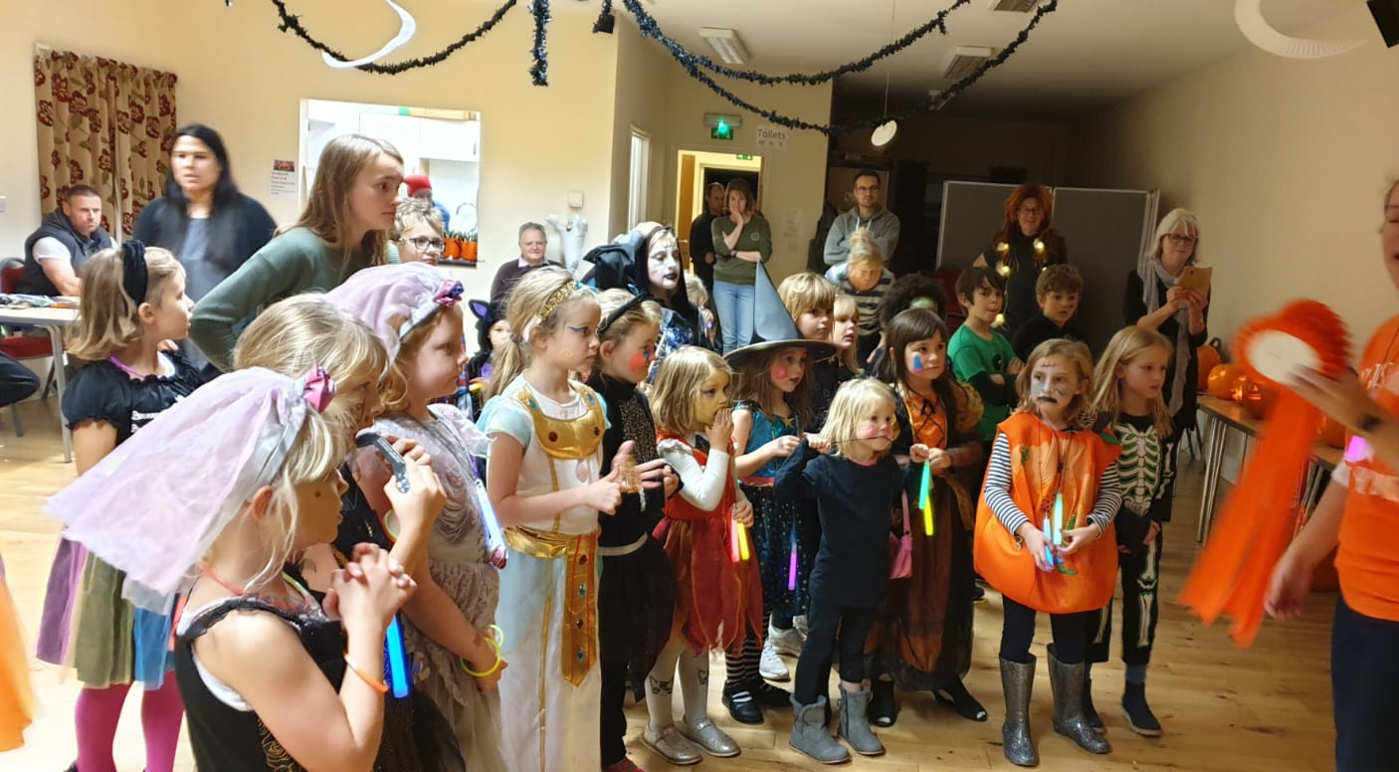
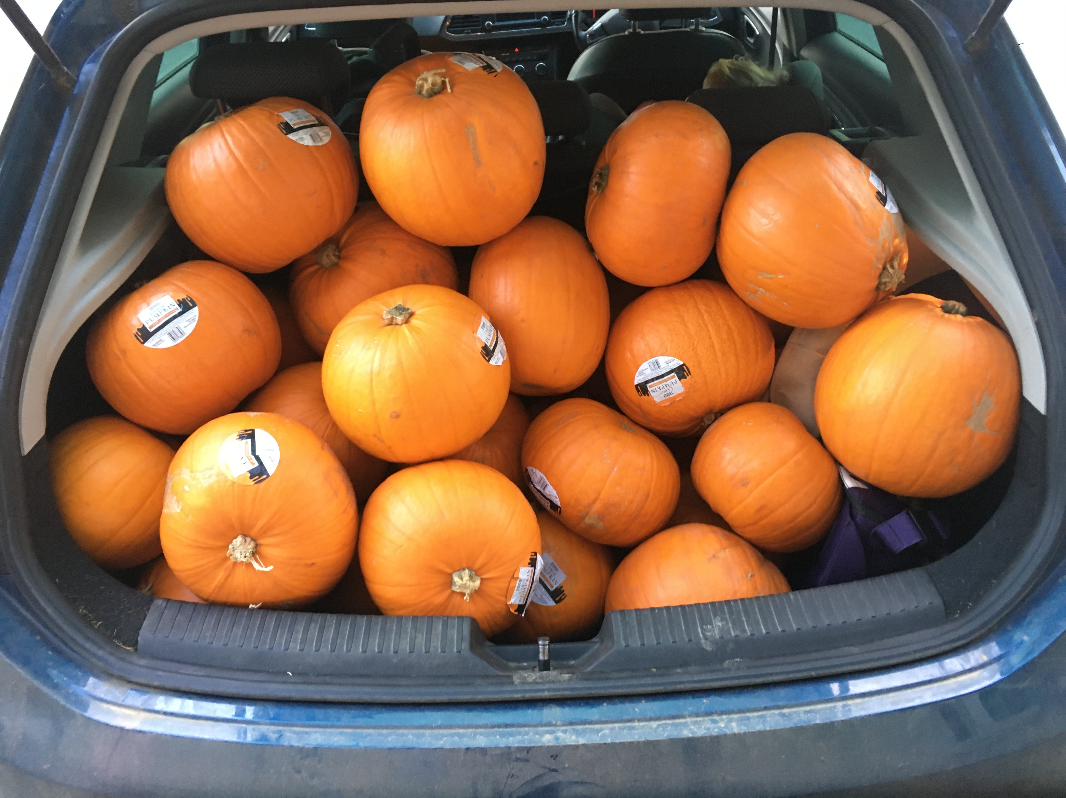
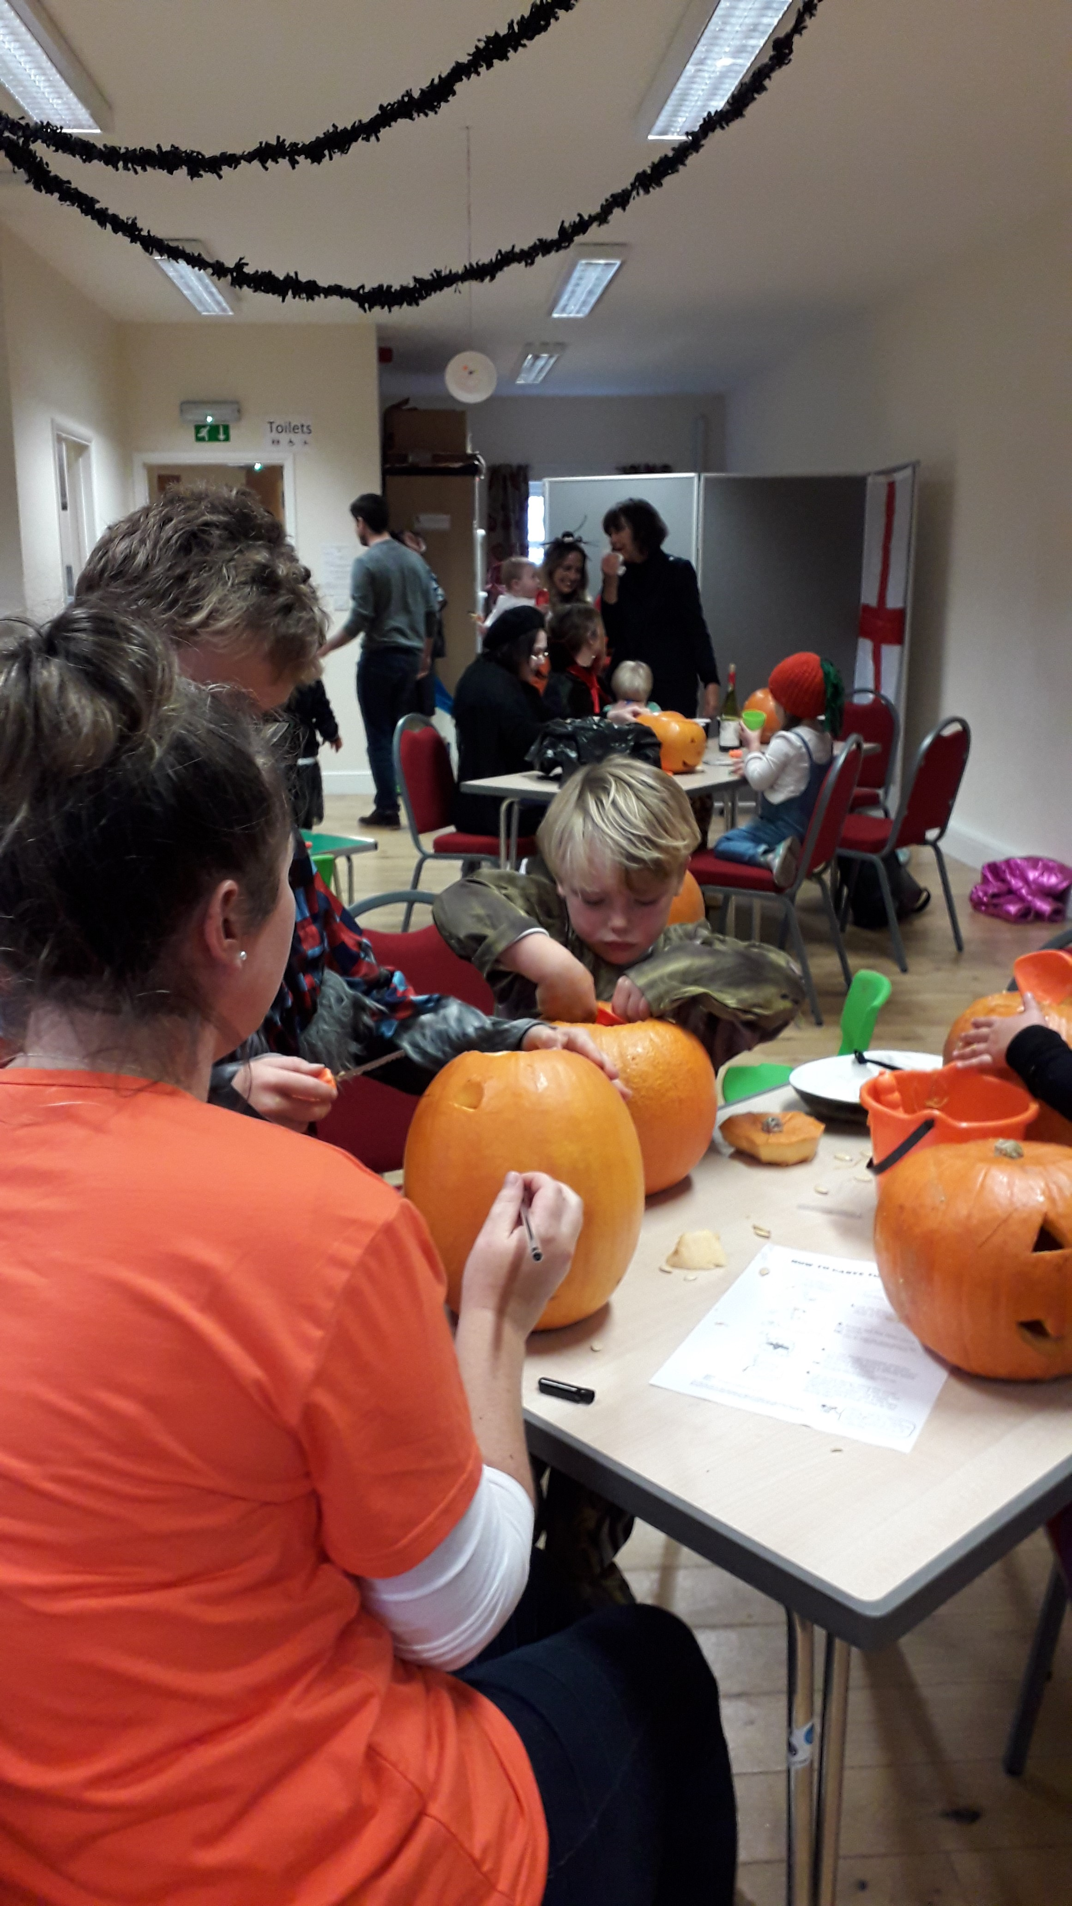

Donations towards the cost of producing the Argus will be gratefully received. Jo and Chris are happy to collect these in the Village Shoppe and Post Office.

Thank you to Tino Capaldi, Becca Miller and Jenny Boyce for cover and internal pictures.
Editorial Comment
November in many ways is a time of reflection. We look back and remember the loss of life of so many in the twentieth centry conflicts. The First World War left an estimated 16 million soldiers and civilians dead and countless others physically and psychologically wounded. What began as quite a small conflict escalated into a global war involving over 30 nations.

It was supposed to be a 'war to end all wars' but just over twenty years later the most deadly conflict in human history began. It raged for six years at a cost of 70 to 85 million fatalities. Most of these casualties were civilians. These included massacres, the genocide of the Holocaust, strategic bombing, premeditated death from starvation and disease and the use of nuclear weapons on Japan.

St. Mary's Church Atherington
www.tworiversmissioncommunity.org

Services
Monday, 11th November 10.50 am at the War Memorial
(followed by refreshments in the Church Hall)

Sunday, 24nd November A church service led by the new team Rector, Rev Gary Owen to be held in the Church Hall at 4.00 pm. Refreshments follow the service with an opportunity to meet the new Rector.

Harvest Festival
The Harvest service which took place on 6th October was a very successful occasion. A bring and share tea was enjoyed by all and the auction of produce raised a magnificent £171.00. Over 40 people attended. Thanks to everyone who donated produce and bought produce.

Christmas Fair

Saturday, 30th November

10.30 to 2.30
in
The Pavilion

Refreshments available all morning as well as soup and rolls from 12.00. Various stalls including cakes, christmas wreaths, gifts, raffle and children's games and much much more.... Come along and support this enjoyable event.

Please keep an eye on the Notice Boards for more information

Christmas Eve – Calling all children

There is going to be a Children's Nativity Play in the church at the Christmas Eve service this year. If any child in the village wants to be involved please contact Marg Maidment on 560498.

So dust off the halos and crowns and dig out the tea towels for this Christmas celebration.

Atherington Children's Playing Field Committee

Photographic Workshop – Saturday, 5th October2019
Earlier this month a small group of people met to take part in this workshop held at the Pavilion. Vic Wardle gave an extremely interesting and informative presentation on photographic techniques and in getting the most out of our cameras.

Thank you Vic for organising this event. Everyone really enjoyed the morning. Thank you also to Nona and her friend for producing some tasty bacon sandwiches to start off the morning.

Beaford Arts Production

The Man Who Planted Trees
2nd November at 7.30 pm at the Pavilion
This is award winning, internationally acclaimed and captivating adaptation of Jean Giono's wonderful environmental cult classic can be seen in the Pavilion THIS SATURDAY. I hope you have bought your tickets. This is an inspiring and unforgettable story that shows us the difference one man (and his dog!) can make to the world.

A production for adults and children. Fliers were sent out in the Argus last month but more are available in the shop. Please come along and support this event. Tickets can still be purchased from the shop or are available on the night.

Dogs on Field

Thank you to everyone who has taken the trouble to write about your views on this subject. We will be looking at all the replies at our next meeting on 18th November as well as general observations made over the period. A final decision will then be made. It is clear that feeling is split on this issue and we are never going to please everyone. Whatever the decision please accept it gracefully even if you do not agree with it.

Halloween and Pumpkin Carving
The village enjoyed a spooky (and some would say noisy, messy, crazy....) evening of pumpkin carving on the 26th October. 40 pumpkins were carved into menacing masks to terrify the judges who had the impossible task of choosing the best of the bunch. Rosettes were awarded for both the most fearful fancy dress and the most creatively carved pumpkin for children and adults. It was fantastic to see what an amazing effort everyone had put in.
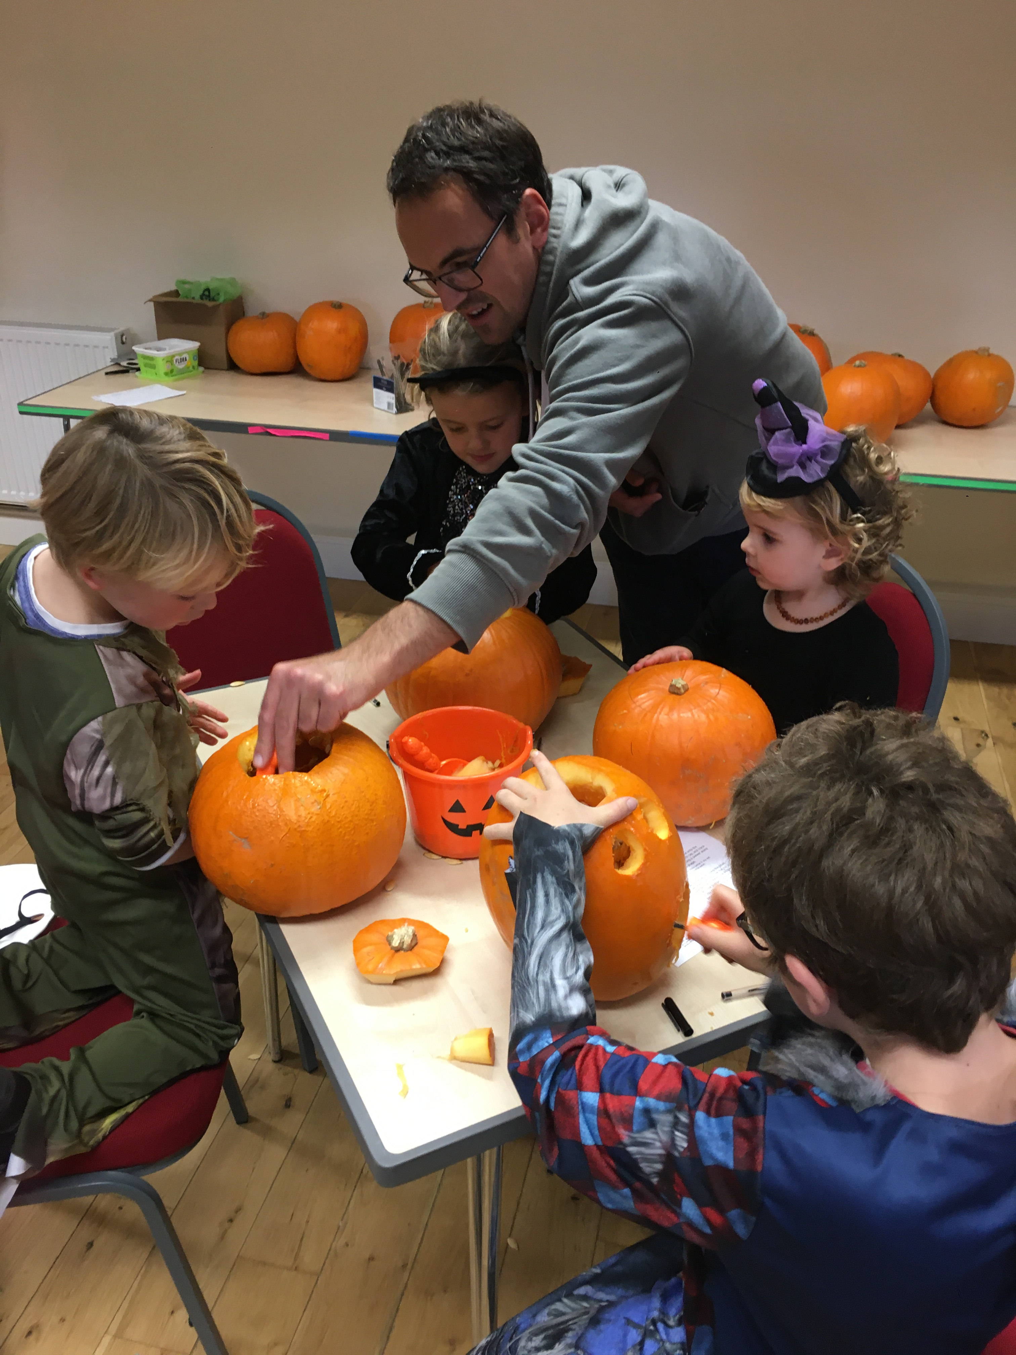
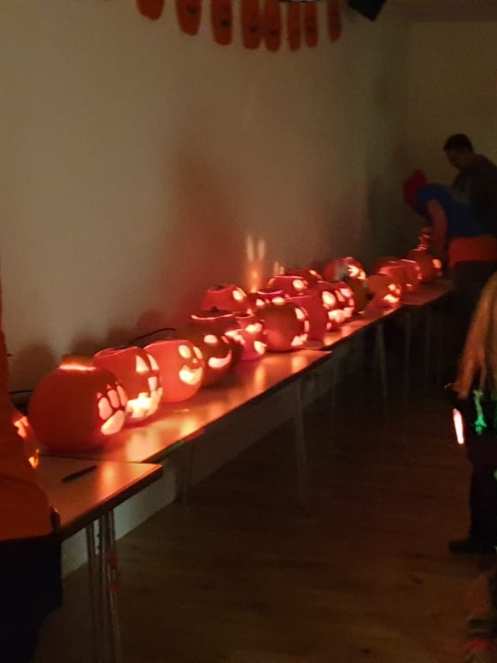

Once the pumpkins had been carved and the BBQ consumed, the lights dimmed and the disco began. Face paints, UV lights, glow sticks and the beat of 'Thriller' through the disco complimented minutes later by 'Baby Shark' created an hour of crazy dancing, giggling and glowing followed by the lighting of the pumpkins which made a spectacular sight. We can't wait for next year!

None of our events would be possible without the generous support of time and effort from so many in the village so a big thank you to everyone involved in helping in the preparation and on the night. Thank you to HC Rosettes for the donation of the prizes. Thanks to Tesco for a raffle prize.

The profit made from the event was £253.22 which will greatly help in the running of the Pavilion.

30th November – a talk about Devon hedgerows and trees
This promises to be an interesting talk and includes latest information from the Forestry Commission on Ash Dieback and other diseases affecting our precious trees. See flier included in this month's edition.

The talk will be £2.50 but you can come along and enjoy a delicious filled jacket potato and salad before the event for an additional £3.50. There will be chilli or cheese fillings plus salad.

Please reserve your potato by giving your names to Jo and Chris in the Village Shoppe. Pay on the night.

Pavilion Cafe

Once a month the Pavilion will be serving lunches and light bites. It is hoped that this will be a social occasion (as well as a tasty one). Dish of the Day will cost £6.00 and snacks and light bites will range from £2.00 to £3.00.

Dish of the Day will have to be ordered in advance by giving your names to Jo and Chris in the Village Shoppe but light bites can be purchased on the day.

The first Pavilion Cafe will be on Monday, 2nd December and will be open from 12.30 pm onwards. Dish of the Day will be chicken and ham pie, mashed potato and peas and carrots. If you would like Dish of the Day please order by the close of day on Thurday, 29th November.

Parish Council

Remembering Walter White

Sunday 1st December
2:30pm
Atherington Pavilion

We would like to invite you all to join us in remembering our late District Councillor and friend, Walter White. Walter gave so much to our Parishes and we felt a lasting tribute like this was appropriate in the village he called home. The afternoon will consist of an unveiling of a memorial plaque (with planted daffodils of course!) followed by cream teas at the Pavilion. We are hoping to create a display with photos of Walter and his poems, it would be great to see your photos of him. Also we would be very grateful to anyone who could donate scones for the afternoon.

If you have any questions, can offer support or any photos/poems please contact Jess on 07775473012 or email texelwoman@hotmail.co.uk. Alternatively you can contact Jenny on 01769 560404 or email andy-jenny.boyce@btconnect.com.

General News

Atherington Acorns
Atherington Acorns is a baby and toddler group for children from new born up to pre-school age which meets every Wednesday morning in the Pavilion between 9.30 and 11 am.

It is a thriving group with families from Atherington as well as the surrounding area. A great place for mums and dads and youngsters to meet new people and make lasting friendships.

Atherington and Umberleigh Defibrillator Fund – TARGET REACHED

As many of you may already know the Safari Lunch was an amazing success. The combined result was a briliant £2205. As donations were kept separate from the lunch takings, Atherington made £845 from the event and along with the previous donations and raised money we have now reached our total.

Because the two villages are now both continuing to be part of the South Western Ambulance Service Foundation Trust, the total we need to reach is lower (£1500).

Reaching the total is a result of total village effort and support. However, on behalf of Atherington, a big thank you must be extended to Jenny Boyce who took the project on board and worked tirelessly to secure the funds.

THANK YOU JENNY

Umberleigh Christian Fellowship – The Church by the Bridge
Sunday Services at 11am.
Pop in for coffee and cake on the first Tuesday of the month 10.30am - 12 noon.
A warm welcome to all.
Further details from 01271 830662 or 560057
Luncheon Club
Contact Tony Squires on 01769 560489 for information. All welcome. The Club meet every 4 weeks to sample different venues. The next date is 14th November and they will be going to Weirmarsh Restaurant.

Puzzle to Solve
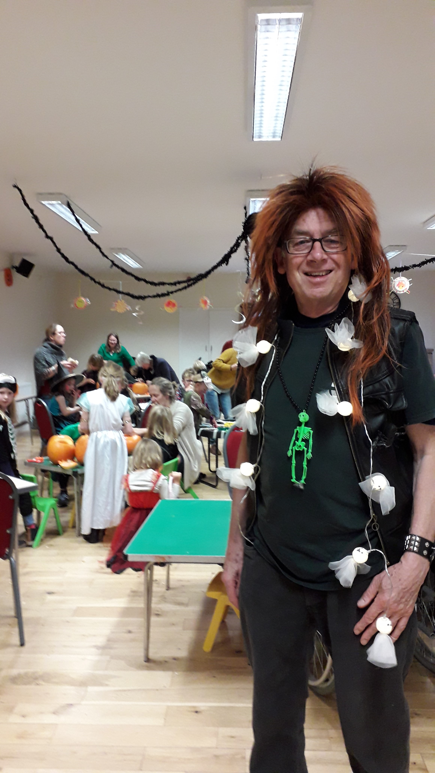
Does anyone recognise this man? He turned up at the pumpkin carving event in Atherington Pavilion thinking it was a '60s' Disco. I hope he got home safely.

Atherington and Umberleigh WI

Last month the WI enjoyed a fascinating talk on the life of a fairground family delivered by Kay Townsend.

This month's meeting will be on 10th November 7.00 pm for 7.30 pm in Umberleigh Village Hall and Chris Braund and Janet Few will be giving a historical talk dressed in appropriate costume.

All visitors welcome. Contact Margaret Maidlow – 01769 560498.

Ladies Tea Circle - Each Wednesday afternoon rotating each week around Members’ homes.

Mobile Library – the mobile library is continuing for the time being. It will be in the square on Tuesday, 12th November 15.05 – 15.35

Poetry Corner
The Soldier
If I should die, think only this of me:
Thats there's some corner of a foreign field
That is for ever England.

Rupert Brooke (died 1915 from sepsis)

Common Form 1914-1918
If any question why we died,
Tell them, because our fathers lied.

Rudyard Kipling (whose only son was killed at the Battle of Loos 1915)

Anthem for Doomed Youth
What passing bells for these who die as cattle?
Only the monstrous anger of the guns
Only the stuttering rifles' rapid rattle
Can patter our their hasty orisons.

Wilfred Owen (died 4th November 1918 in France)

Christmas: 1924
“Peace on Earth!” was said. We sing it,
And pay a million priests to bring it.
After two thousand years of mass
We've got as far as poison gas.

Thomas Hardy (appalled by the events of the First World War)

Bus Timetable - Operated by Turner Tours Route 325
Tuesday, Thursday, and Friday service only. No Service on Bank Holidays

Atherington – Barnstaple | T,Th,F
Atherington Church (Eastbound) | 10:19
Bishops Tawton, Mount Pleasant (Northwest bound) | 10:32
Barnstaple, Bus Station (Stand B) | 10:40
Barnstaple – Atherington | T,Th,F
Barnstaple, Bus Station (Stand B) | 13.30
Bishops Tawton, The Bridge (Southeast bound) | 13.40
Atherington Post Office | 13.51

Atherington Businesses Directory
Ashwood Joinery Martin Huggins 01769561154
Atherington Acorns Playgroup Katherine Broad 07766088639
Avon Linda Brayley 01769 560572
Chantry Nursery Mr. Martin 01769 560347
Daisy Park (daisypark.co.uk) Emma Paisley 01769 579077
General Builder Tim Rose 01769 560410
HC Rosettes Claire Large 01769 560556
Lilcott Farm Julie and Mark 07846 397823
Pet shop 2 Go (petshop2go.co.uk) 01769 736637
Sea Breeze (Painter and decorator) Dave Scott 01769 560758
Smity Hair Salon Alison Montague 01769 560046
Sports Massage Therapist Abi Hanafin 07866 686021
Thatcher Ian Rose 01769 560031
Thatchit (thatchit.com) Toby Rose 07935 066041
Village Shoppe and Post Office Chris and Jo Hart 01769 560248
Contact Jo Hart if you would like to add your Village Business or Group to the list

Other Contacts
Safer Atherington Streets Group – www.saferatheringtonstreets.org.uk
Atherington Conservation Area – www.athconv.wordpress.com
Parish Council - http://atheringtonparishcouncil.org.uk/index.html
Atherington Children's Playing Field – Atheringtoncpf@hotmail.com

Hire of one of Atherington’s Halls
For availability and rates contact: -
St Mary’s Parish Church Hall – Mrs Margaret Maidlow 01769 560498
The Pavilion – in the Playing Field – Mrs Alison Montague 01769 560529

News Gatherer and Co-ordinator, Jo Hart 01769 560248:
Editor, Jill Thorne 01769 560096
Email: atheringtonargus@outlook.com
Collated in house at Atherington
Facebook Group: Atherington Community page
© Atherington Argus 2019, All Rights Reserved
The Atherington Argus is a not for profit community news publication supported by voluntary contributions
Articles about News and Events in Atherington are accepted for publication in person at the Village Shoppe or in digital format (Word or pdf) to our email address above.
COPY DEADLINE FOR THE NEXT EDITION IS 28 th November
Publication date around 1st of the month

